Social Media Kit for National Hospice Palliative Care Week (2022)
Living in Colour - #LivingInColour #NHPCW
Copy and Post
For this National Hospice Palliative Care Week, we encourage you to share your stories on social media! Who made your grey days a little brighter? What helps you Live in Colour? Tag CHPCA on Facebook (@CanadianHospicePalliativeCare) and Twitter (@CanadianHPCAssn) and tell us about those who mean the most to you! Don’t forget to use the hashtags #LivingInColour and #NHPCW
Facebook
May 1st to 7th marks National Hospice Palliative Care Week in Canada. We’re celebrating by highlighting how hospice palliative care supports Canadians so they can enjoy #LivingInColour from beginning to end. #NHPCW
Find out more at https://chpca.ca/week
The heart of hospice palliative care is the belief that every person deserves a vibrant beautiful life, from beginning to end. For National Hospice Palliative Care Week 2022, we celebrate how hospice palliative care helps people to embrace the kaleidoscope of life by #LivingInColour! #NHPCW
Find out more at https://chpca.ca/week
Every Canadian deserves a beautiful, colourful, and vibrant life up until the very end. Join us and @CanadianHospicePalliativeCare to advocate for better access to hospice palliative care from coast to coast to coast! #NHPCW #LivingInColour
Find out more at https://chpca.ca/week
In honour of National Hospice Palliative Care Week, comment & tell us how hospice palliative care brought colour and joy to your or a loved one’s life? #LivingInColour #NHPCW
Happy National Hospice Palliative Care Week! Our goal is for all Canadians to receive quality #hospice #palliativecare. Visit https://chpca.ca/week to learn more and see how you can get involved!
Colouring pages
A life is a work of art – created and coloured by our experiences, relationships, and with love. Print the #LivingInColour colouring pages from @CanadianHospicePalliativeCare for some creative fun that highlights the beauty of hospice palliative care. Find them here: https://chpca.ca/week#colouringpages
#NHPCW
May 1st to 7th, 2022 is National Hospice Palliative Care Week. Canadians from all walks of life benefit from great hospice palliative care. Download the #LivingInColour poster and colouring pages from @CanadianHospicePalliativeCare to express how hospice palliative care helps you live in colour! Available here: https://chpca.ca/week#colouringpages #NHPCW
What helps you to Live in Colour? Draw on the @CanadianHospicePalliativeCare colouring pages and share the colours of YOUR life with those around you! Print them here: https://chpca.ca/week#colouringpages
#NHPCW #LivingInColour

Twitter
May 1st to 7th marks National Hospice Palliative Care Week in Canada. We’re celebrating by highlighting how #hospice #palliativecare supports Canadians so they can enjoy #LivingInColour from beginning to end. #NHPCW
The heart of #hospice #palliativecare is the belief that every person deserves a vibrant beautiful life, from beginning to end. For #NHPCW 2022, we celebrate how #HPC helps people to embrace the kaleidoscope of life by #LivingInColour! Find out more at https://chpca.ca/week
Every Canadian deserves a beautiful, colourful, and vibrant life up until the very end. Join @CanadianHPCAssn in advocating for better access to #hospice #palliativecare from coast to coast to coast! Find out more at https://chpca.ca/week
In honour of #NHPCW, comment & tell us how #hospice #palliativecare brought colour and joy to your or a loved one’s life? #LivingInColour
Happy National Hospice Palliative Care Week! Our goal is for all Canadians to receive quality #hospice #palliativecare. Visit https://chpca.ca/week to learn more and see how you can get involved! #LivingInColour #NHPCW
Colouring pages
A life is a work of art – created and coloured by our experiences, relationships, and with love. Print CHPCA's #LivingInColour colouring pages for some creative fun that highlights the beauty of #hospice #palliativecare. Find them here: https://chpca.ca/week#colouringpages
May 1st to 7th, 2022 is National Hospice Palliative Care Week. Canadians from all walks of life benefit from great #hospice #palliativecare. Download @CanadianHPCAssn’s #LivingInColour poster and colouring pages to express how #HPC helps you live in colour! Available here: https://chpca.ca/week#colouringpages
What helps you to Live in Colour? Draw on @CanadianHPCAssn’s colouring pages and share the colours of YOUR life with those around you! Print them here: https://chpca.ca/week#colouringpages #NHPCW #LivingInColour

On any platform – Topic specific
Download the images from our website at: https://chpca.ca/week#socialimages
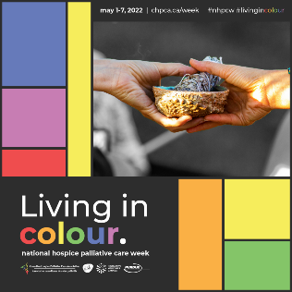
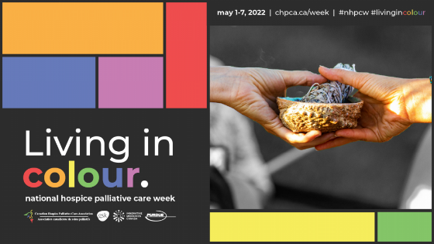
Spiritual & Cultural Needs

Quality #hospice #palliativecare includes support for, and inclusion of your spiritual and cultural practices because we know that for you to live in colour, your whole self should be supported and celebrated! #NHPCW #LivingInColour
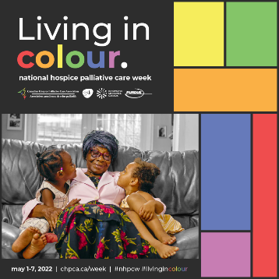
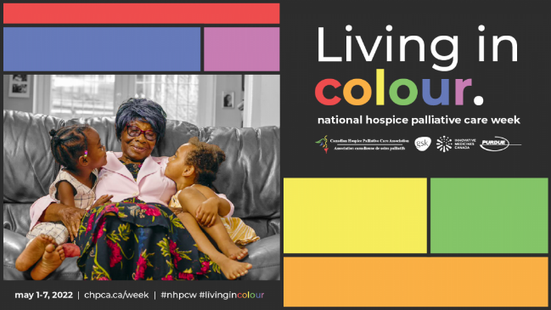
Family

Your #family and loved ones are an important part of your life – so they’re an important part of #hospice #palliativecare too! #LivingInColour #NHPCW
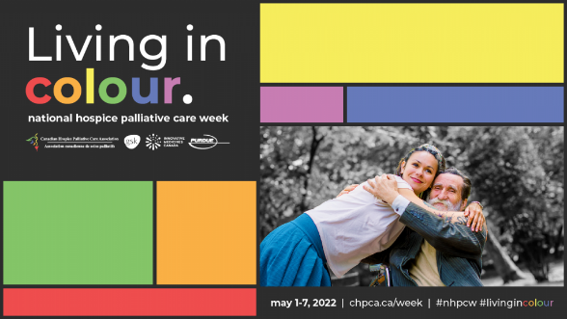
Team & Community
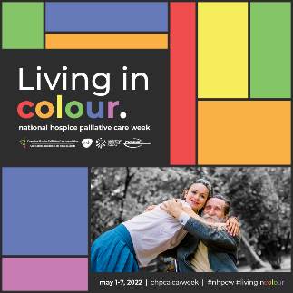

It takes a village! This #NHPCW, we thank all the staff, volunteers, & community members who do their part to provide quality #hospice #palliativecare in Canada - you bring colour to all our lives with your dedication, your #compassion and your smiles! #gratitude #LivingInColour

